**TABLES**

**USER REGISTRATION TABLE**

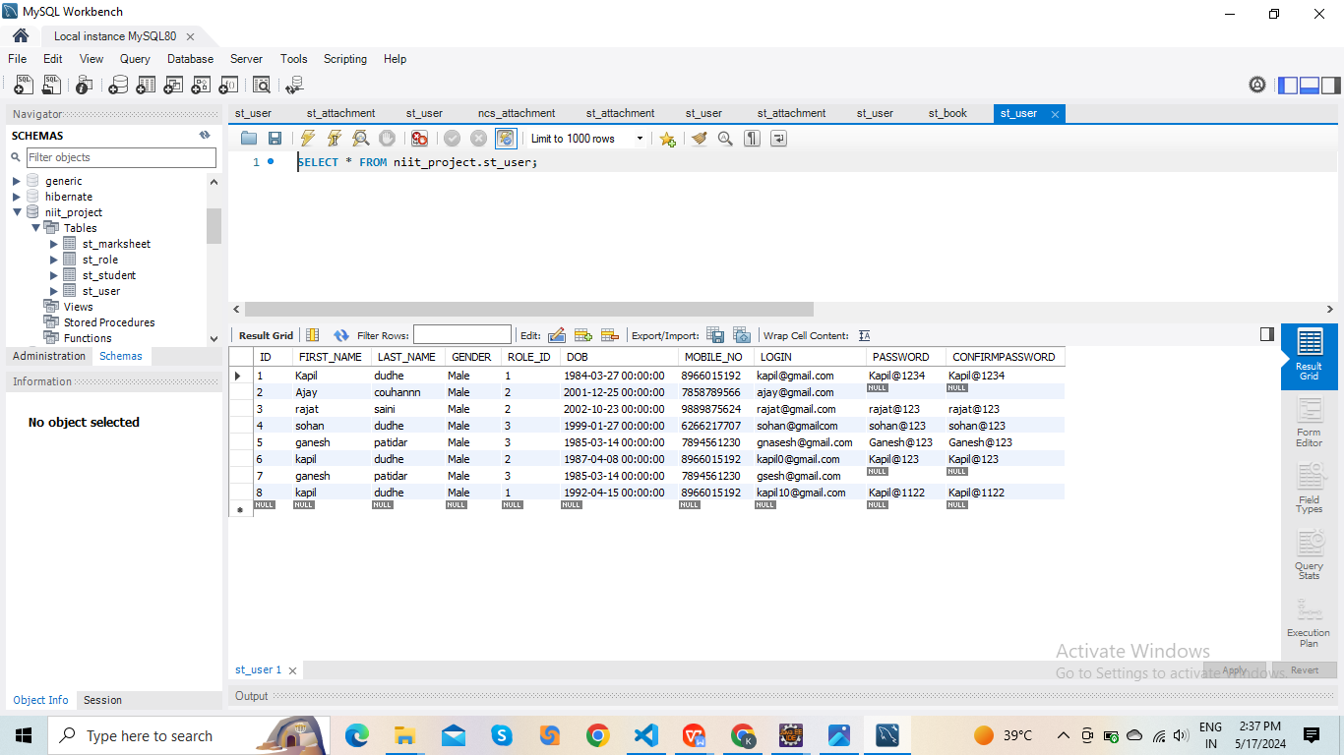

**STUDENT EXAMINATION TABLE**

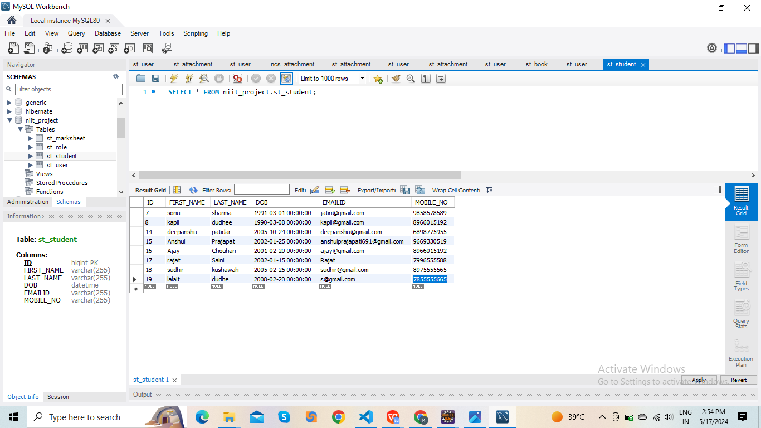

**ROLE EXAMINATION TABLE**

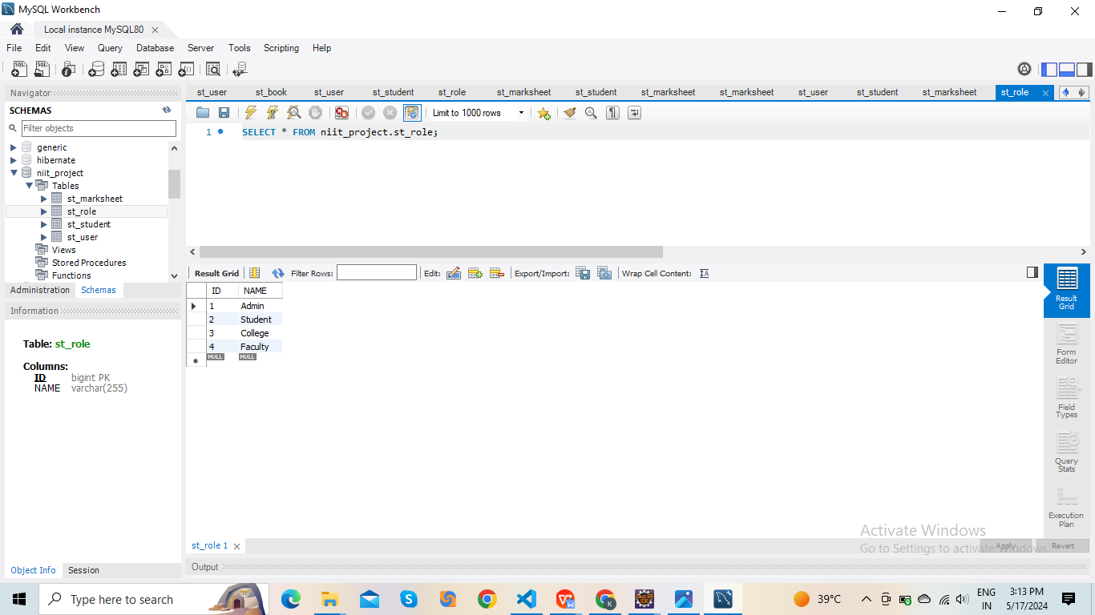

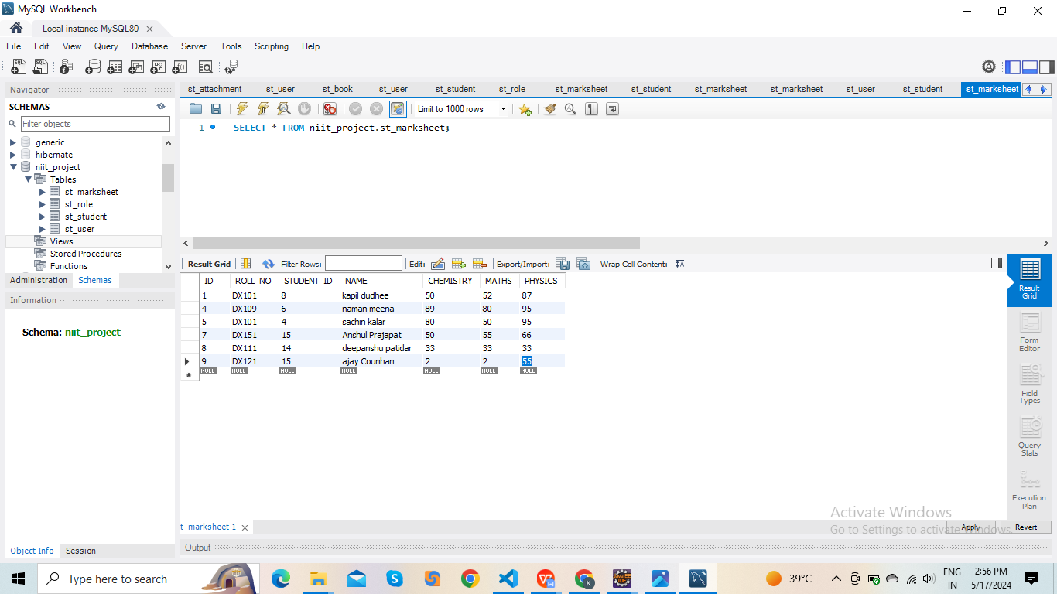**MARKSHEET TABLE EXAMINATION**